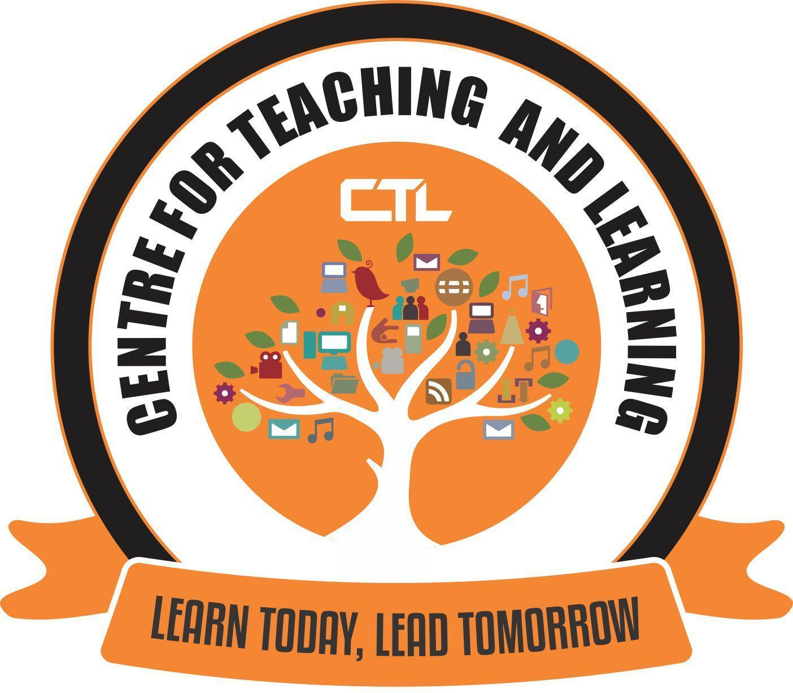
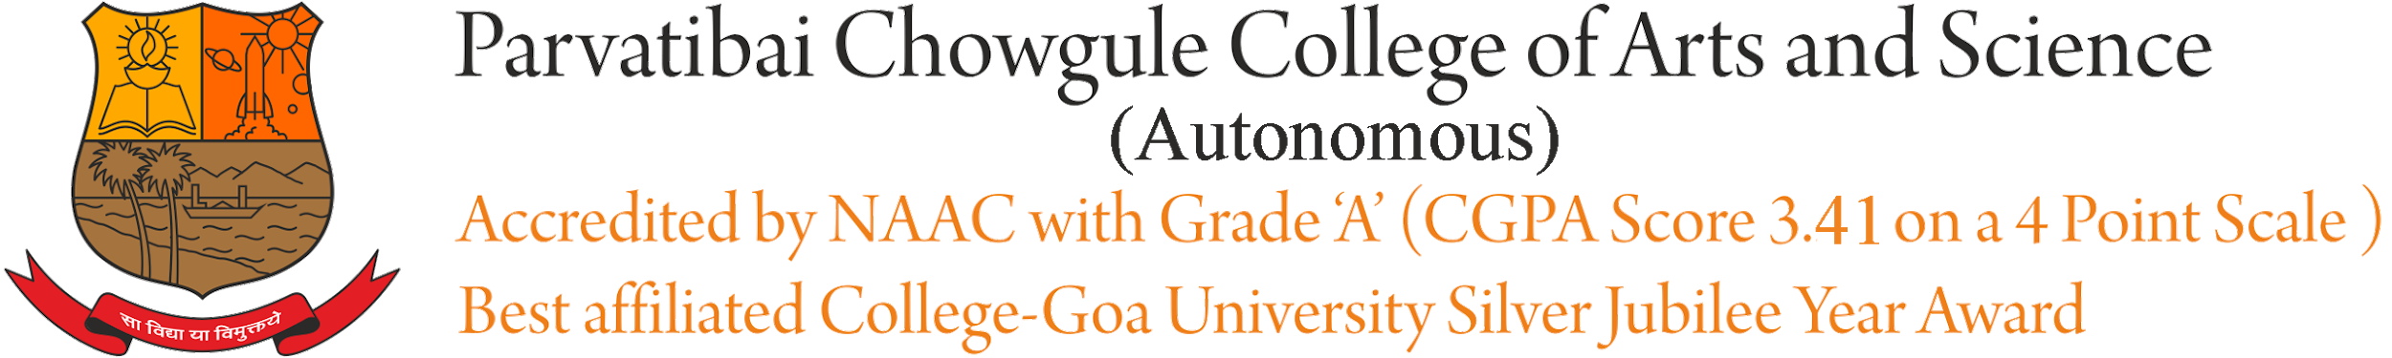

CENTRE FOR TEACHING AND LEARNING

REPORT ON
Title: | EXPERT FDP WEBINAR SERIES - VI
Date and year: | 29th April, 2021 (Thursday)
Venue: | GMEET
Resource person/s: | Dr.R.C.Sharma, Associate Professor Instructional Design & Educational Technology, Ambedkar University, New Delhi
Organising Committee | Center for Teaching Learning
No. of Participants: | 28
Objective: | Perspectives of NEP 2020 : Technology in Education
Summary of the proceedings: | The Session began by Welcome by Dr.Sameena Falleiro followed by the Offg.Principal Dr.Shaila Ghanti giving the introductory address. Dr.Sameena then introduced the Resource Person who then delivered his talk.  The following are the various areas of NEP 2020 that he highlighted in his presentation:  - Life Long Self Directed Learners  - Knowledge Seekers  - Competence; Comprehension and Cognitive Flexibility  - Digital Learning & Evaluation Ecosystem  - Learning Paths  - Efficacy of Instruction  This FDP focussed on certain terminologies/annotations used in the NEP; It also focussed on Learning Paths and Competencies so that Faculty can use techniques in teaching, learning and evaluation so that we can create students who are self-directed lifelong learners.  This was followed by a Q n A.  The webinar ended with a Vote of Thanks given by the HOD of Computer Science Mrs.Suchitra Bhat.
Photographs:

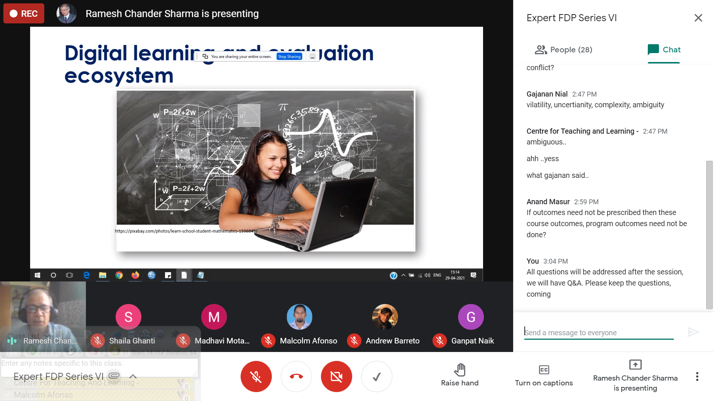

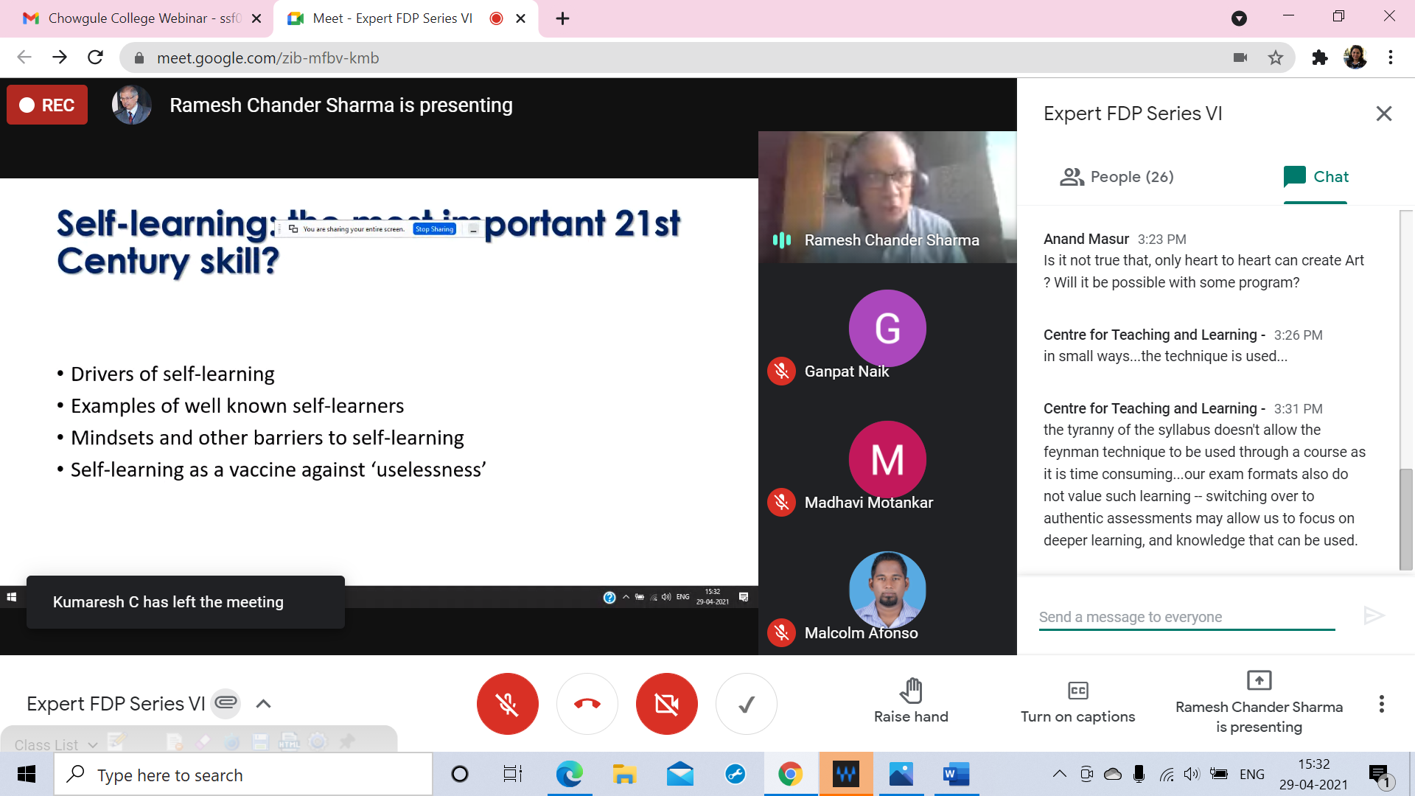

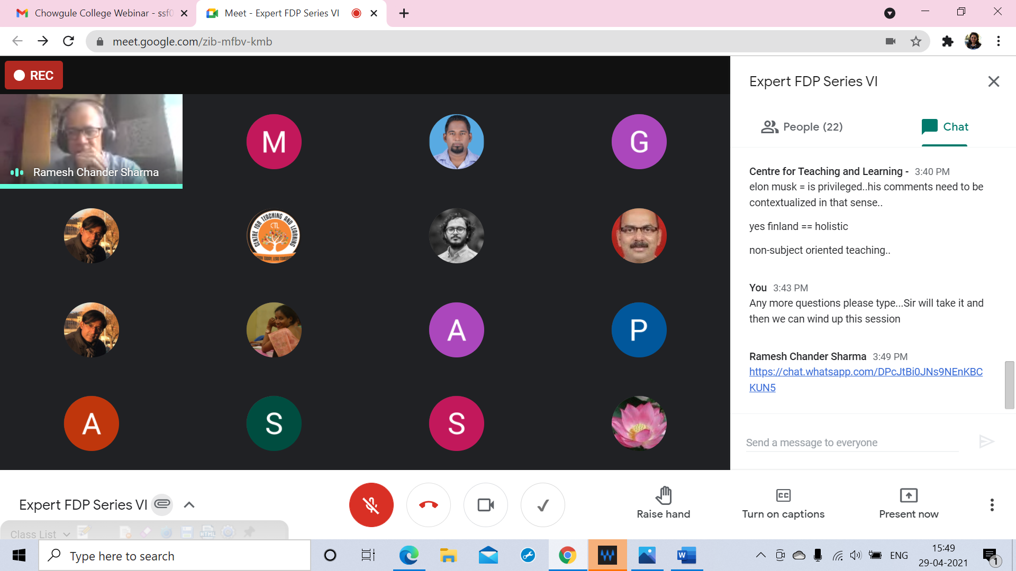

Report Prepared by: Dr.(Ms).Sameena Falleiro
Centre Director-CTL

